Myschool Redesign Document

GHOH-T-216-Problem Solving Assignment 1

# Review

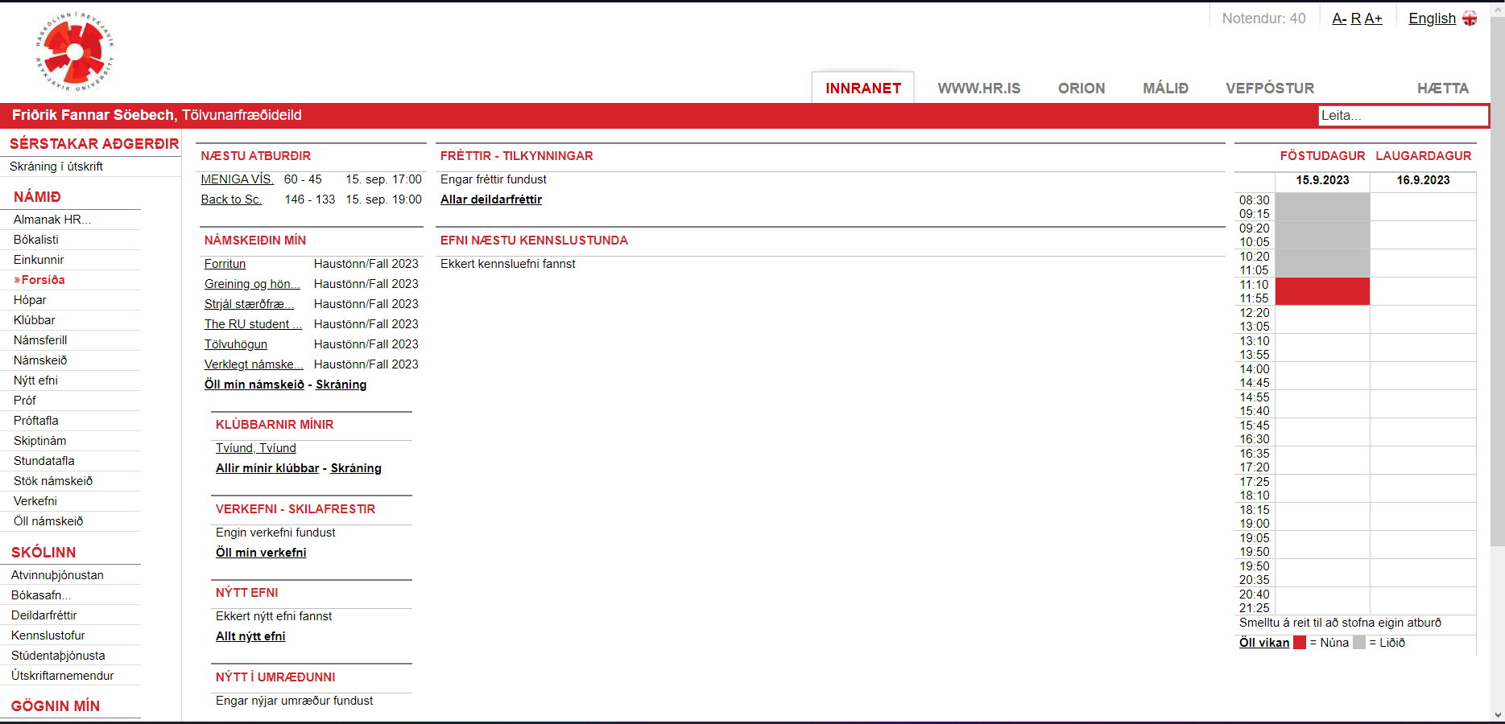Myschool immediately as you enter has a glaring problem with visibility. Its quite an eyesore to look at all the buttons and normal text be styled the exact same and there is just way too much information on the screen to digest.

This problem gets exacerbated on mobile phones as the page does not size to the phone’s screen but stays the exact same as the picture above.

There is also either unclear or entirely unnecessary information on screen such as the number of current users and font size settings.

1. Users do not require the information of how many people are currently accessing the platform and
2. I don’t blame anyone for not knowing you can increase the font size on the page because if you haven’t seen it yet the buttons to do so are “A- R A+”.

Here is also a button on the left vs normal text on the right, very minute difference and hard to tell them apart.

So, to summarize the gripes I have with this user interface:

1. Overabundance of information to digest.

2. Unclear distinction between buttons and text.

3. The webpage not scaling to phone screens.

1. Unimportant information on the page.
2. Accessibility options unclear.

# Redesign

To start the redesign, we must do something about all these sections that are cluttering the front page so I decided to move it off to the menu so that separate pages can server the separate functions that the sections did before.

This now means that the settings to change how things look for accessibility reasons are more clearly communicated than before.

Having buttons be bordered and filled in helps distinguish them from normal text on the page as well.

The button here is at the bottom and formatted separately from normal non-interactive text.

Adding settings to the navigation menu as seen above should help people find the right settings that they need to be able to use the site. The only option that should always be on screen should be language options so that the navigation text can be understood.

Now onto the problem of scaling down to screens. The design that I’ve come up with I believe is very easy to scale down to other screens if the menu turns into a collapsible menu on the side.

Here on the left is the scaled down version with the menu collapsed in, very clean concise easy to read information,

and on the right the menu is collapsed out, as you can see all the previous sections fit perfectly with even more room to expand in the future.

# Final designs

Now after showing each fix individually here is the finished redesign of Myschool:

And its mobile counterpart:

# Conclusion

I think this redesign would take Myschool from being an unreadable mess to being a comprehensive tool that anyone would have an easy time understanding and would make managing events and courses a more enjoyable experience for all users on any device. If the other sub pages created by this change follow the same schema and the preexisting ones too it would, in my opinion, improve Myschool by ten folds.

Thank you so much for reading this paper on how we could improve this tool for all students and teachers alike. Hope these changes may see the light of day.